1.4 Project:
User Interactions and I/O
Michael Stoller
ECPI – SDC220L
Professor Ryan Simpson
10/10/2026

User Interactions and I/O
GitHub Link: https://github.com/micsto7893/SDC220L
PART 1
Calculator Application Design Plan
1. Introduction and Overview
I will be developing a calculator application that performs basic math operations. The calculator will support:
- Addition
- Subtraction
- Multiplication
- Division
- Calculations using multiple numbers
This calculator will also be capable of handling incorrect user input without crashing.
2. Application Startup and Welcome Screen
Once loaded, you will see a welcome message and a display of the available mathematical operations. The welcome screen will look something like this:
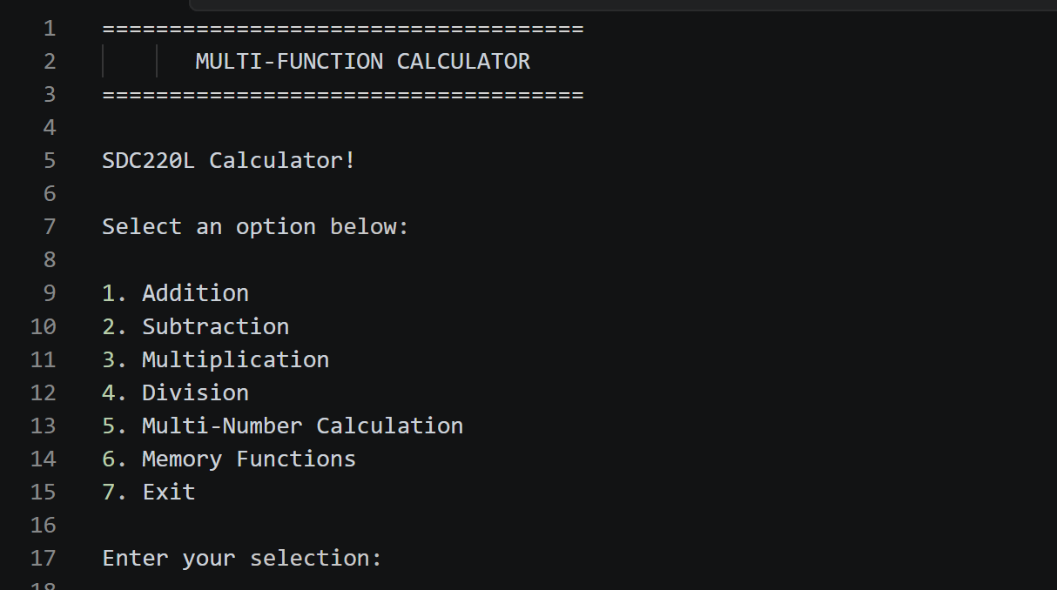
3. User Input and Mathematical Operations
The application will use a menu-driven system to select the mathematical operations. For standard calculations, the user will select an operation and then enter two numbers individually. For example:
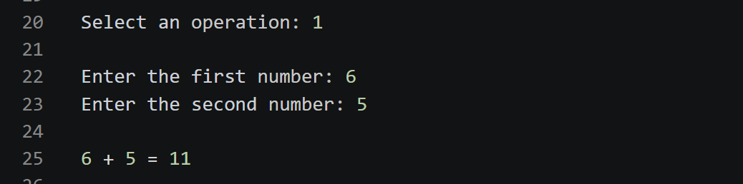
If there are multiple numbers, the user will select the multi-number option, followed by the operation and then specify how many numbers they want to use, and enter each number individually. For example:
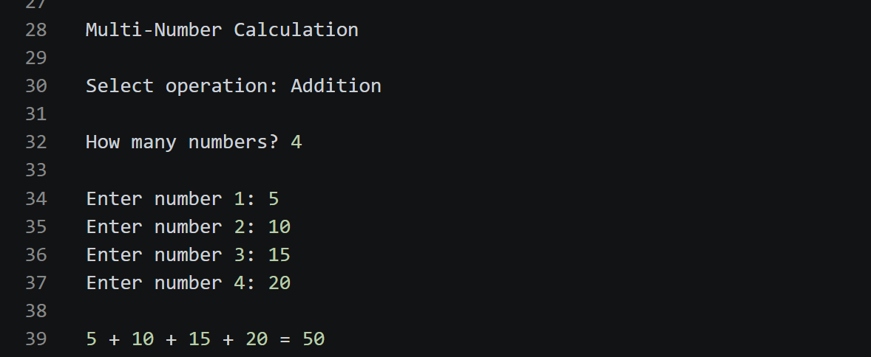

4. Displaying Calculation Results
The calculator will display both the problem and the calculated result. Results will display up to two decimal places. Whole numbers will be displayed without decimal places. After displaying a result, it will provide the option to perform another calculation or return to the main menu.
5. Error Handling and Invalid Input
Will also be adding an error handling so when something doesn’t go to plan there are clear instructions. Such as non-number input, dividing by zero, or entering a not available menu selection:
Non-number input:
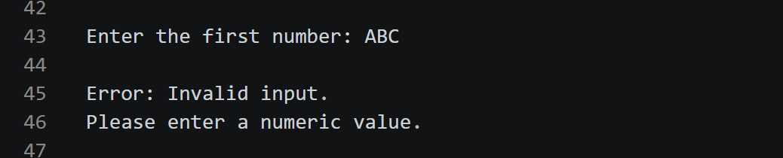
Divide by zero:
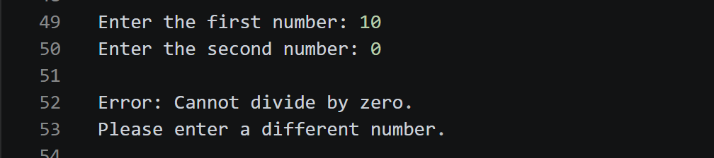
Not available menu selection:
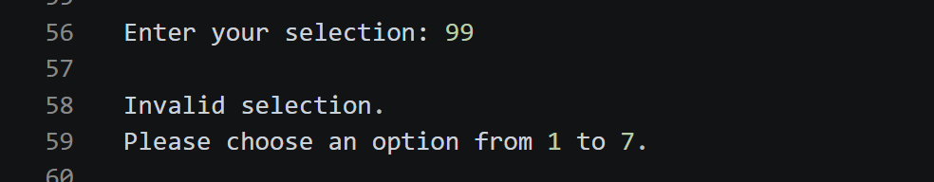

6. Memory Functions
The calculator will include memory functionality, allowing users to store a calculation result and retrieve it. The memory menu will provide the following options:
- Store Result: Saves the most recent calculation result.
- Recall Memory: Displays the stored value and allows the user to use it in another calculation.
- Clear Memory: Removes the stored value.
- Return to Main Menu: Returns to the main calculator menu.
Only one value will be stored at a time. Saving a new value will replace the previous one. So, if the user tries to recall a value when memory is empty, it will display a message explaining that no value is currently stored.
7. Exiting the Application
You will be able to exit the calculator by selecting option 7 from the main menu. Before closing, the application will display a brief message:


PART 2
